Credentials

🗝️ What Are Credentials?
# Source: AI Source: Provided by: [Data Path: Persons Table -> ID Column: 1, Name_En Column: Motasem Essam] -> From: [ChatGPT] on [1/18/2026]
Credentials are pieces of information used to prove your identity to a system, application, or service — just like a username and password help you log into a website.

✅ Simple Definition:
# Source: AI Source: Provided by: [Data Path: Persons Table -> ID Column: 1, Name_En Column: Motasem Essam] -> From: [ChatGPT] on [1/18/2026]
Credentials = Login details that authenticate a user or application.

🔐 Common Types of Credentials
# Source: AI Source: Provided by: [Data Path: Persons Table -> ID Column: 1, Name_En Column: Motasem Essam] -> From: [ChatGPT] on [1/18/2026]
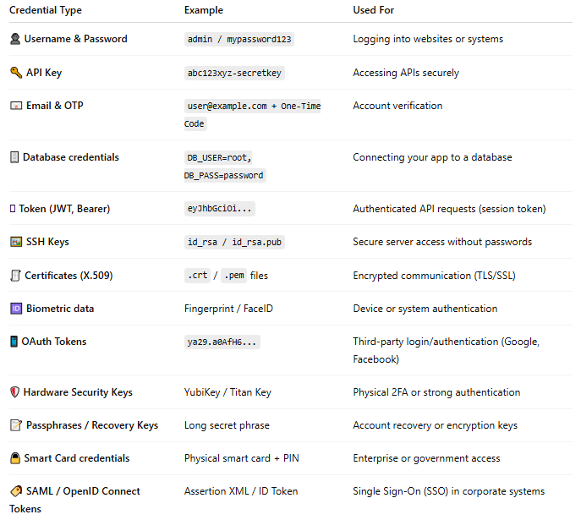

Credential Type | Example | Used For
👤 Username & Password | admin / mypassword123 | Logging into websites or systems
🔑 API Key | abc123xyz-secretkey | Accessing APIs securely
📧 Email & OTP | user@example.com + One-Time Code | Account verification
🗄️ Database credentials | DB_USER=root, DB_PASS=password | Connecting your app to a database
🪪 Token (JWT, Bearer) | eyJhbGciOi... | Authenticated API requests (session token)
🖼️ SSH Keys | id_rsa / id_rsa.pub | Secure server access without passwords
🧾 Certificates (X.509) | .crt / .pem files | Encrypted communication (TLS/SSL)
🆔 Biometric data | Fingerprint / FaceID | Device or system authentication
📱 OAuth Tokens | ya29.a0AfH6... | Third-party login/authentication (Google, Facebook)
🛡️ Hardware Security Keys | YubiKey / Titan Key | Physical 2FA or strong authentication
📝 Passphrases / Recovery Keys | Long secret phrase | Account recovery or encryption keys
🔒 Smart Card credentials | Physical smart card + PIN | Enterprise or government access
🏷️ SAML / OpenID Connect Tokens | Assertion XML / ID Token | Single Sign-On (SSO) in corporate systems

📌 Where Are Credentials Used?

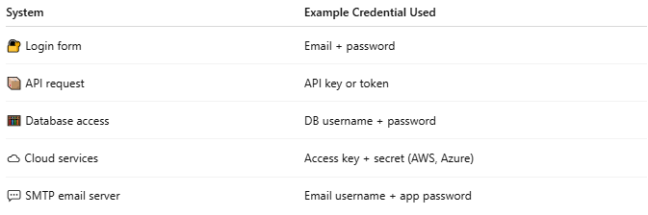

System | Example Credential Used
🔐 Login form | Email + password
📦 API request | API key or token
🧮 Database access | DB username + password
☁️ Cloud services | Access key + secret (AWS, Azure)
💬 SMTP email server | Email username + app password

⚠️ Best Practices for Credentials
# Source: AI Source: Provided by: [Data Path: Persons Table -> ID Column: 1, Name_En Column: Motasem Essam] -> From: [ChatGPT] on [1/18/2026]
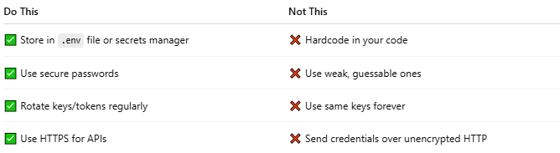

Do This | Not This
✅ Store in .env file or secrets manager | ❌ Hardcode in your code
✅ Use secure passwords | ❌ Use weak, guessable ones
✅ Rotate keys/tokens regularly | ❌ Use same keys forever
✅ Use HTTPS for APIs | ❌ Send credentials over unencrypted HTTP

🧰 Goal: Secure Database Connection Using Credentials
# Source: AI Source: Provided by: [Data Path: Persons Table -> ID Column: 1, Name_En Column: Motasem Essam] -> From: [ChatGPT] on [1/18/2026]
Great! Let’s walk through a simple, secure example of how to use credentials in a PHP project — such as for connecting to a MySQL database using .env and PDO.

📁 Step 1: Create a .env File
# Source: AI Source: Provided by: [Data Path: Persons Table -> ID Column: 1, Name_En Column: Motasem Essam] -> From: [ChatGPT] on [1/18/2026]
In your project folder, create a file named .env with your database credentials:
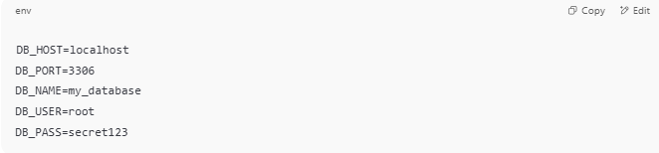
DB_HOST=localhost
DB_PORT=3306
DB_NAME=my_database
DB_USER=root
DB_PASS=secret123

❗ Never upload this file to GitHub. Add .env to .gitignore.

🧰 Step 2: Install PHP Dotenv (if using Composer)
# Source: AI Source: Provided by: [Data Path: Persons Table -> ID Column: 1, Name_En Column: Motasem Essam] -> From: [ChatGPT] on [1/18/2026]
If you're using Composer:
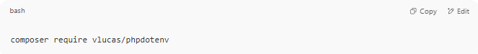
composer require vlucas/phpdotenv

🧾 Step 3: Create a PHP Script (e.g., connect.php)
# Source: AI Source: Provided by: [Data Path: Persons Table -> ID Column: 1, Name_En Column: Motasem Essam] -> From: [ChatGPT] on [1/18/2026]
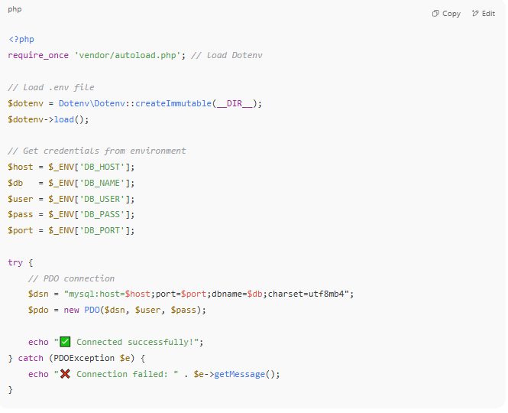

<?php
require_once 'vendor/autoload.php'; // load Dotenv

// Load .env file
$dotenv = Dotenv\Dotenv::createImmutable(__DIR__);
$dotenv->load();

// Get credentials from environment
$host = $_ENV['DB_HOST'];
$db = $_ENV['DB_NAME'];
$user = $_ENV['DB_USER'];
$pass = $_ENV['DB_PASS'];
$port = $_ENV['DB_PORT'];

try {
// PDO connection
$dsn = "mysql:host=$host;port=$port;dbname=$db;charset=utf8mb4";
$pdo = new PDO($dsn, $user, $pass);

echo "✅ Connected successfully!";
} catch (PDOException $e) {
echo "❌ Connection failed: " . $e->getMessage();
}

🧪 Step 4: Run the Code
# Source: AI Source: Provided by: [Data Path: Persons Table -> ID Column: 1, Name_En Column: Motasem Essam] -> From: [ChatGPT] on [1/18/2026]
Use a browser (if web-based) or CLI:
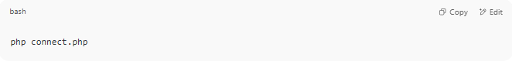
php connect.php

You should see:
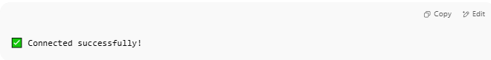
✅ Connected successfully!

🛡️ Why This Is Safe
# Source: AI Source: Provided by: [Data Path: Persons Table -> ID Column: 1, Name_En Column: Motasem Essam] -> From: [ChatGPT] on [1/18/2026]
- Credentials are not hardcoded.
- You can change values without editing code.
- It's scalable and works on local/dev/prod environments.

🔄 Want a JavaScript/Node.js Example Too?
# Source: AI Source: Provided by: [Data Path: Persons Table -> ID Column: 1, Name_En Column: Motasem Essam] -> From: [ChatGPT] on [1/18/2026]
Or maybe:
- Connect using API credentials (not DB)?
- Send secure email with SMTP credentials?
Let me know your goal, and I’ll tailor the example for it!

🧠 In Summary
# Source: AI Source: Provided by: [Data Path: Persons Table -> ID Column: 1, Name_En Column: Motasem Essam] -> From: [ChatGPT] on [1/18/2026]
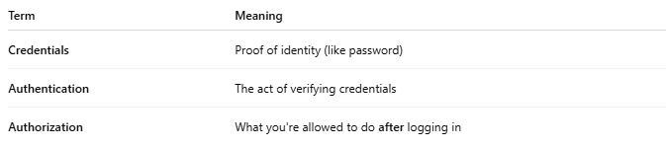

Term | Meaning
Credentials | Proof of identity (like password)
Authentication | The act of verifying credentials
Authorization | What you're allowed to do after logging in

